Author: Jessica Cathro

2024

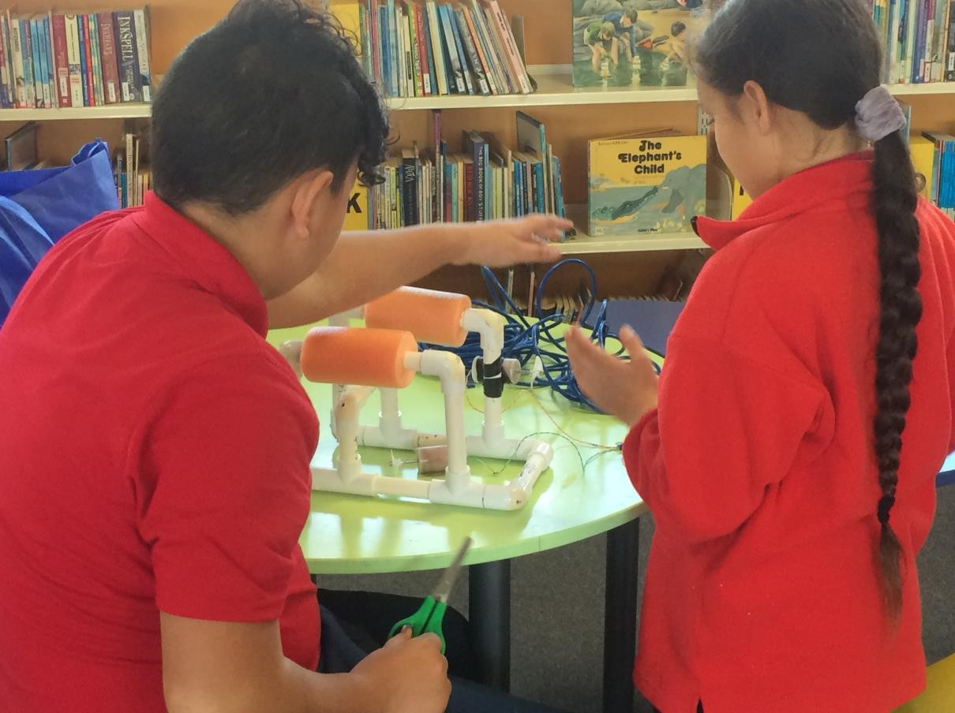



NZAquabots

Student Build Guide

Contents

Getting started – What you Need 2

Step 1: 3

Step 2: 4

Step 3: 4

Step 4: 5

Step 5: 5

Step 6: 7

Step 7 8

Step 8 9

Step 9 10

Step 10 11

Credits and Acknowledgements 12

Getting started – What you Need

**Tools**

* Eye protection (optional)
* Ruler/tape measure
* Vivid/marker pen
* Hacksaw
* Wire strippers
* Needle nosed pliers
* Electric hand drill
* Fine Sandpaper
* Alcohol wipes
* Vice
* ¼” Drill bit
* 3/32” Drill bit
* Soldering iron
* Craft knife
* Scissors
* Disposable Gloves
* Small magnetic screwdriver

**Materials**

* 1.8 m or 6x 1 foot lengths ½” PVC pipe
* 10x ½” PVC elbows
* 4x ½” PVC tees
* Pool noodle
* Electrical tape
* Masking tape
* 15 m CAT 5 Tether Cable with RJ-45 Connector Installed on one end
* 3x 35 mm Film canisters, with caps
* 3x 12-Volt DC motors
* 3x Propellers
* 3x 4-40 Threaded propeller shaft Couplers
* 3x 4-40 Tee nuts
* 3x 4-40 Lock nuts
* 1x Super glue
* 1/3x Wax bowl ring
* Monkey Putty

**Other Resources**

* Newspaper
* Waste paper
* Paper towels
* Electronic device (laptop, tablet)
* Camera
* Coloured paper
* Pens
* Pencils
* Rulers

Step 1:

**Measure out your pipe**

When you have measured your pipe it is HIGHLY recommended that you write the size in INCHES on the pipe. Make the mark on the pipe quite long so you can see where to cut.

**List of Pieces you need**

Use the check list to make sure you have measured out all your pieces of pipe.

|  |  |  |  |
| --- | --- | --- | --- |
| ❑ | * Two Pieces – 6.5” (16.5 cm) long | * ❑ | * Four Pieces – 5” (12.7 cm) long |
| ❑ | * Two Pieces – 4½” (11.4 cm) long | * ❑ | * Two Pieces – 4” (10.2 cm) long |
| ❑ | * Two Pieces – 2½” (6.4 cm) long | * ❑ | * Four Pieces – 1½” (3.8 cm) long |

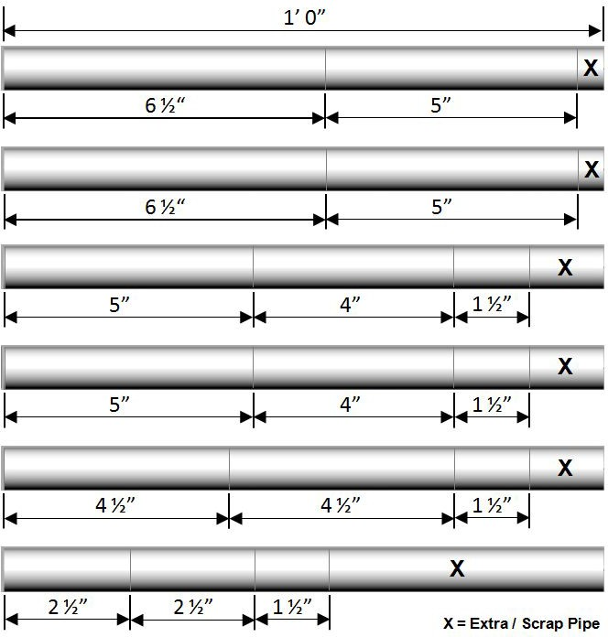

ADULT - check that each group/team has all the pipes correctly measured and labelled before proceeding.

**Review Health and Safety for Using Hacksaws:**

**COMMON ERRORS**

* Students will measure the inches as cm instead e.g. 6.5cm = 6.5”
* Students will try to arrange the measurements in a different way than the pipe diagram
* Students will forget to measure a piece of pipe
* Students will measure a measurement on top of another one, i.e. 16.5cm with a 10cm marked on it as well
* Put the pipe into the vice
* Ensure that the line to cut is approximately between 2cm and 5cm from the edge of the vice
* Keep hands away from the blade
* Make straight cuts with the blade – keep the blade straight
* Rest your other hand on the vice to provide balance
* Have teams cut all their pipe pieces out. Get them to double check that they have all the right pieces.
* NB: if pipes are 1cm out they are ok, if they are several centimeters out they need to be recut

Step 2:

**Drilling Holes in Your Elbows**

Place the elbow in the vice with one of the end pointing up towards the sky. Tighten the vice. Place the drill bit into the open end and drill through the end until you make a hole.

.

**COMMON ERRORS**

* Placing the elbow upside down
* The drill bit falls out
* They drill through both sides of the elbow

**Review Health and Safety for Using Drills:**

* Never drill anything in your hand
* Always use the vice
* Press down as you drill
* Press the trigger slowly till the bit has gripped
* Keep hands out of the way
* Take finger off the trigger immediately if you feel unsafe or the drill slips
* Hold the drill vertically and slowly press the trigger. When the drill bit has really dug into the pipe then speed up the drill. Ensure that you press down so the drill drills into the pipe
* Stop once it has gone through the pipe.

Step 3:

**Tape Up Your Motors**

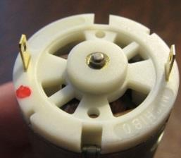

Use your marker to colour in the gold connector that is next to the red dot.

**COMMON ERRORS**

* Colouring in both gold connectors
* Not taping the top of the motors
* Layering more than one layer of tape

Use the electrical tape to tape all-round the side of the motors. Then cutting

pieces of tape, tape across the top of the motor. Tape across the bottom of the motor so that the wax cannot get in.

Step 4:

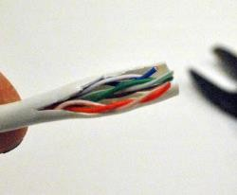**Strip Your Wires**

**COMMON ERRORS**

* Cutting all the way through the copper wire
* Stripping too much of the plastic off the copper wire
* Not stripping enough of the plastic off the copper wire
* Only having one strand of copper wire
* Cutting off any wire except the brown one

Use a craft knife to gently cut through the plastic, like gutting an eel. Continue for about 50cm. Then peel the plastic off and cut the plastic off.

Use the wire strippers to cut through the Ethernet cable to expose the four wires inside.

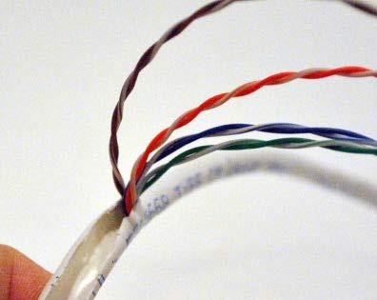Cut the brown one off at the same point you cut the plastic off. We do not need this wire.

Strip the coloured plastic off each of the cables so that approximately 2cm of copper wire is exposed.

**Review Health and Safety for Using Craft Knives:**

* Never cut anything in your hand
* Hold the cable in place with your fingers
* Cut away from you
* Cut small pieces at a time
* Move your fingers out of the way

Step 5:

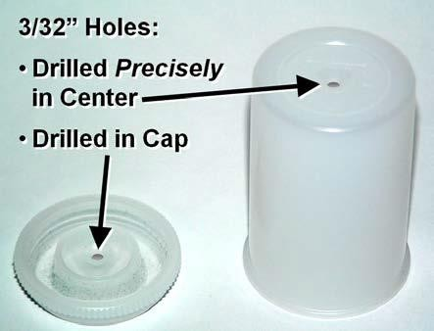Press the lid onto the canister and hold the canister at the bottom on the table.

It is important that the hole is drilled exactly in the middle of the canister, to allow the motor shaft to go through.

Drill gently through the lid using a small drill bit. Turn the canister over and drill through the bottom. Repeat for all the canisters

**Review Health and Safety for Using Drills:**

* Never drill anything in your hand
* Press down gently as you drill
* Keep hands out of the way
* Take finger off the trigger immediately if you feel unsafe or the drill slips
* Press the reverse switch to pull the drill out of the hole

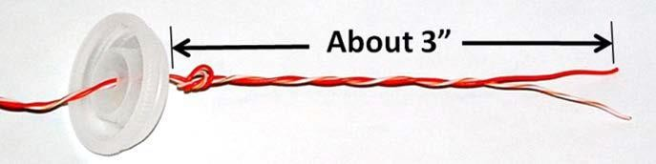

Take the cable that you have stripped and slide the paired colours through the hole in the lid. Make sure the lid will still close. There should be about 5cm of cable inside the lid, then tie a knot on the inside of the lid.

**COMMON ERRORS**

* Threading the wires through the wrong way
* Only drilling one part of the canister
* Using the big drill bit

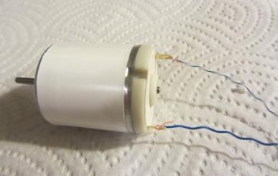Take the stripy cable and twist it around the gold connector that is NOT coloured in.

Take the solid cable and twist is around the connector that is coloured in.

Make sure NO plastic is touching the gold connectors

Connect all the motors. Plug the ethernet cable into the controller. Connect the black alligator clip to the black terminal on the battery and the red alligator clip to the red terminal on the battery.

Test your motors all work.

**Troubleshooting if my motors don’t go:**

***If none of the motors go***

* Have you connected the alligator clips correctly?
* Try a different controller
* Try a different battery

***If one/two motors don’t go:***

* Is the copper wired twisted/connected?
* Is there plastic touching the gold connectors?
* Have you connected the solid to the connector that was coloured in?
* Are both wires connected?

Step 6:

**Solder your connections**

We are going to solder the connection between the ethernet cable and the motors.

**COMMON ERRORS**

* Holding the soldering iron off the connection
* Not feeding the solder in
* Only soldering a small bit of the connection

Line up the copper connection and the wire (ensuring that there is NO plastic between these) and rest the solder on the connection.

Bring the soldering iron down into contact with the solder. Feed the solder in as it melts. Ensure that the soldering iron is in contact with the copper connection.

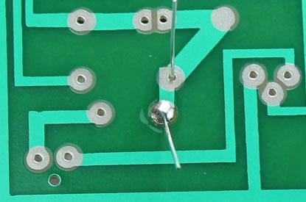If the solder sticks, simply touch the soldering iron to it and it will melt.

A good solid connection should look like a smooth volcano. Check that the connection is soldered around the whole copper connection. Repeat for all the wires/copper connections.

**Review Health and Safety for Using Soldering Irons:**

* Wait until the soldering iron has heated up
* Always put the soldering iron back into the stand if you are not using it (that includes when adjusting the motors or solder)
* If helping stay on the opposite side of the person’s writing hand,
* i.e. if you are helping a left handed person stay on their right hand side
* Keep a length of around 10cm of solder
* Wash your hands after soldering
* Never touch the soldering iron anywhere other than the handle
* Never muck around with the soldering iron
* Hold the soldering iron like a pencil

Test all the connections to make sure that the motors go.

**Troubleshooting IF my motors don’t go:**

If none of the motors go

* Have you connected the alligator clips correctly?
* Try a different controller
* Try a different battery

If one/two motors don’t go:

* Is the copper wire soldered?
* Is there plastic touching the gold connectors?
* Are both wires soldered?

**Ideas to go further – for senior students or students who have participated before**

* Explain the difference between welding and soldering
* Explain why plastic being soldered into the circuit might cause the circuit to fail
* Solder the PCB controller together
* Focus on a quality solder connection

Step 7

**Building Your Robot**

Use the image below to put your robot together. Make sure that you press each join together firmly so that it doesn’t fall apart. Once you have tested your robot in the pool for the first time you can then superglue joints together if you need/want to.

**COMMON ERRORS**

* Discovering that pipes are not the same length
* Not putting the pool noodle on

You need to label each pipe with the inches measurement so that you can easily put the robot together. The pipe may need to be firmly pressed through the pool noodle depending on the size of the pool noodle hole.

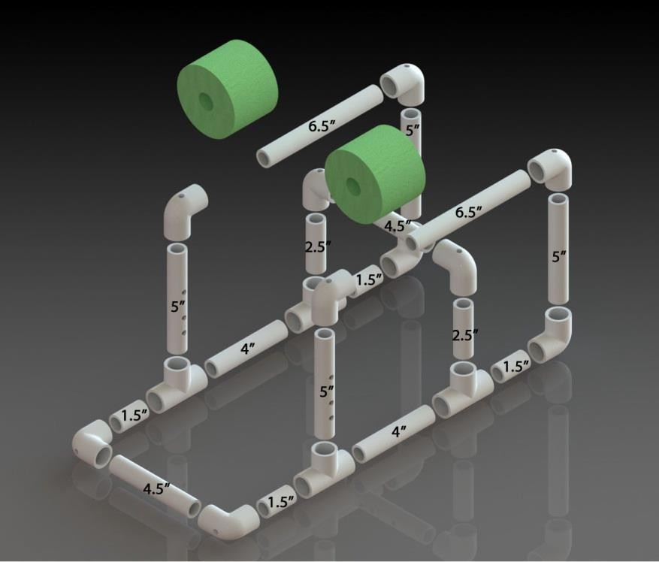

Step 8

**Review Health and Safety for Using Toilet Wax:**

* Put gloves on
* Keep gloves on until the final test and the lid on the canisters is closed
* Make sure that there is paper under your working area
* Don’t eat or taste the wax

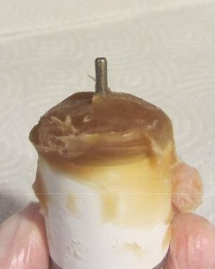

**Toilet Wax for Motors**

Take a ball of wax and put it around the end of the motor with the shaft. You should put enough wax on to the thickness of one adult finger.

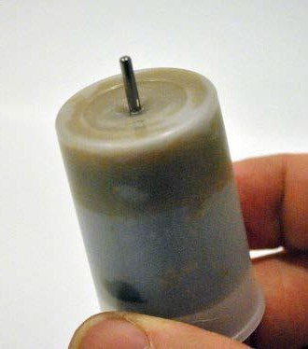

Gently push the motor into the canister so the shaft pokes through the hole – you may need to turn the motor a little to line the shaft up correctly. Press the motor down until the shaft fully pokes out of the canister.

Test the motor still works.

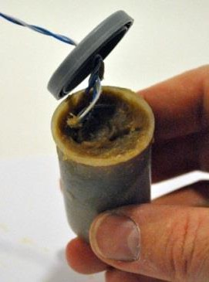Curl up the cable and add wax to the top of the canister to hold

the cable in. Fill the top of the motor and press the lid on. There should be no cable hanging out the sides and no empty space between the wax and the lid.

Test the motor to make sure it still works.

**COMMON ERRORS**

* Not enough wax
* Too much wax
* Wax on the sides of the motors
* Solder connection is broken while putting the wax on/motor into the canister

**Troubleshooting if my motors don’t go**:

If none of the motors go

* Have you connected the alligator clips correctly?
* Try a different controller
* Try a different battery

If one/two motors don’t go:

* Remove the wax and check the connection is still soldered

If motors go slowly:

* Hold the controller down for forwards or backwards until the motor moves fast (the wax needs be loosened from the shaft.

**Monkey Putty**

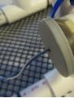This is your last line of defense to waterproof your motors. The monkey putty is the little black lump.

Place some around the lid of the canister where the cable goes into it. This stops the water running down the cable and into your motor.

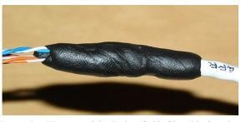Place the final amount around the end of the cable where it meets in the Ethernet cable.

**COMMON ERRORS**

* Putting putty on the groves in the lid, not around the cable
* Putting the putty around the propeller shaft
* Not putting putty on the Ethernet cable end

This stops the water running up your Ethernet cable and into your controller.

Step 9

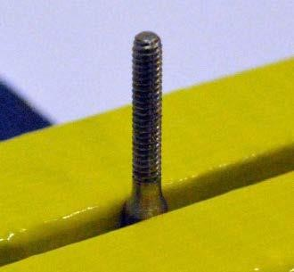**Putting Your Propellers Together**

Put the threaded coupler into the vice with the thread face up.

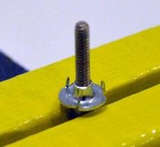

Screw on the nut (which has the points on it) all the way to the bottom. Make sure the points are facing upwards (like in the diagram on the left).

Place the propeller onto the coupler with the groove facing down.

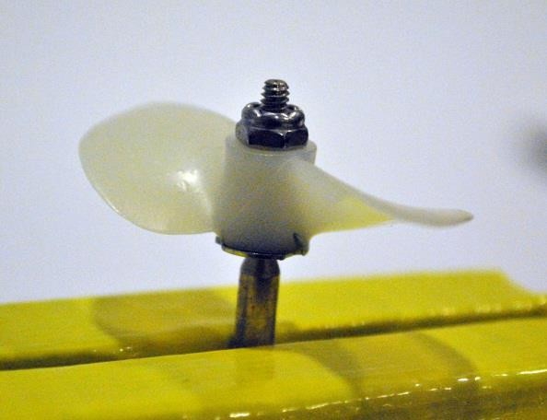Screw on the nut. NB: It is VERY IMPORTANT that the nut is screwed down until it can go no further. The propeller should NOT spin freely.

**COMMON ERRORS**

* Putting the propeller on upside down
* Not screwing the nut on tight enough
* Testing the motors before 10 mins
* Not cleaning the shaft

When this is done, ensure that the motor shaft is clear of all wax – use an alcohol wipe to clean it. Next run the sandpaper up and down the motor shaft to roughen in. Again, clean the shaft with an alcohol wipe – not the same one as before get a new one so that no wax goes onto the shaft. Drip a couple of drops of superglue into the hollow end AND onto the shaft. Slide the coupler onto the shaft all the way down.

Leave to dry for at least 10mins before testing.

Step 10

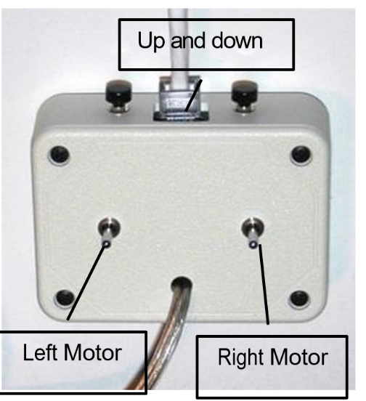Test your motors to determine which motor is connected to the up and down buttons on the controller, the left and the right.

Ensure that the left motor is attached to the left of the Aquabot and the right to the right side.

For your motors to be effective you need to determine the best location for your motors.

For the left and right motors, you need to decide if they will be inside the Aquabot or outside the Aquabot.

Then you need to choose where on the vertical you will attach them. It is important that the motors are level with each other so that you can turn accurately.

It is best to attach your motors with tape to start with. You can later attach them with cable ties or stay with tape. Tape is easier to remove if you choose to move your motors after testing.

**COMMON ERRORS**

* Not testing which motor is which
* Putting the motors on the front of the robot
* Putting the motors on backwards

Credits and Acknowledgements

Photos and images

Step 1:

Image 1 – protoolreviews.com Image 2 – shutterstock.com Image 3 – youtube.com

Image 4 – familyhandyman.com Image 5 – Sea Perch Build Manual Image 6- clipart-library.com

Step 2:

Image 1 – ehow.com Image 2 – wikihow.com Image 3 – youtube.com Image 4 – ebay.com

Image 5 – pvcfittingsonline.com Image 6 – easyscienceforkids.com Image 7 – education.vic.gov.au

Step 3:

Image 1 - <https://archive.org/details/GravityCartoon> Image 2 – youtube.com

Image 3 – studiousguy.com Image 4

Image 5 -

Image 6 – tes.com Image 7 – pinterest.com Image 8 – wired.com

Image 9 – Sea Perch Build Manual

Step 4:

Image 1 – k8schoollessons.com

Image 2 – Sea Perch Construction Manual Image 3 - Sea Perch Construction Manual

Step 5:

Image 1 - Sea Perch Construction Manual Image 2 - Sea Perch Construction Manual Image 3 - Sea Perch Construction Manual

Step 6:

Image 1 – manufacturingstories.com

Step 7:

Image 1 – en.wikipedia.org Image 2 – ozanerhansha.github.io Image 3 – youtube.com

Image 4 - entertainment.howstuffworks.com Image 5 - aqua4balance.com

Image 6 – aqua4balance.com

Image 7 - Sea Perch Construction Manual

Step 8:

Image 1 – thoughtco.com

Image 2 – worldofbiochemistry.blogspot.com Image3 - Sea Perch Construction Manual

Image 4 - Sea Perch Construction Manual Image 5 - Sea Perch Construction Manual

Step 9:

Image 1 – revolvy.com Image 2 – gcaptain.com

Image 3 - Sea Perch Construction Manual Image 4 - Sea Perch Construction Manual Image 5 - Sea Perch Construction Manual

Step 10:

Image 1 - Sea Perch Construction Manual Image 2 - Sea Perch Construction Manual

Acknowledgements:

Jazper Hamilton – Science review

Amy Cornelison – Science Review

Seaperch USA – Sea Perch Construction Manual and build resources